Subject: RE: ORG CPS — clarification on savings for the two clusters
To: Sergej Petrovski <sergej.petrovski@siemens.com>
Cc: Lars Marin (tecracer) | From: Ebrahim Ramadan <ebrahim@cast.ai> | Date: 2026-10-08
——————————————————————————————————————————————
Hello Sergej,
Thanks for raising this. I reviewed both clusters again this morning against the CAST AI console and reporting API. The key point is that neither cluster currently shows negative total realized savings. The negative value you noticed is the Workload Autoscaler attribution for periods when workload requests were increased. Details and screenshots are below.
Claim 1 — Both clusters currently show positive total realized savings.
At ORG CPS level, the October Savings Report shows a baseline spend of $6,841 and an actual spend of $3,849, resulting in +$2,992 realized savings for October 1–8.
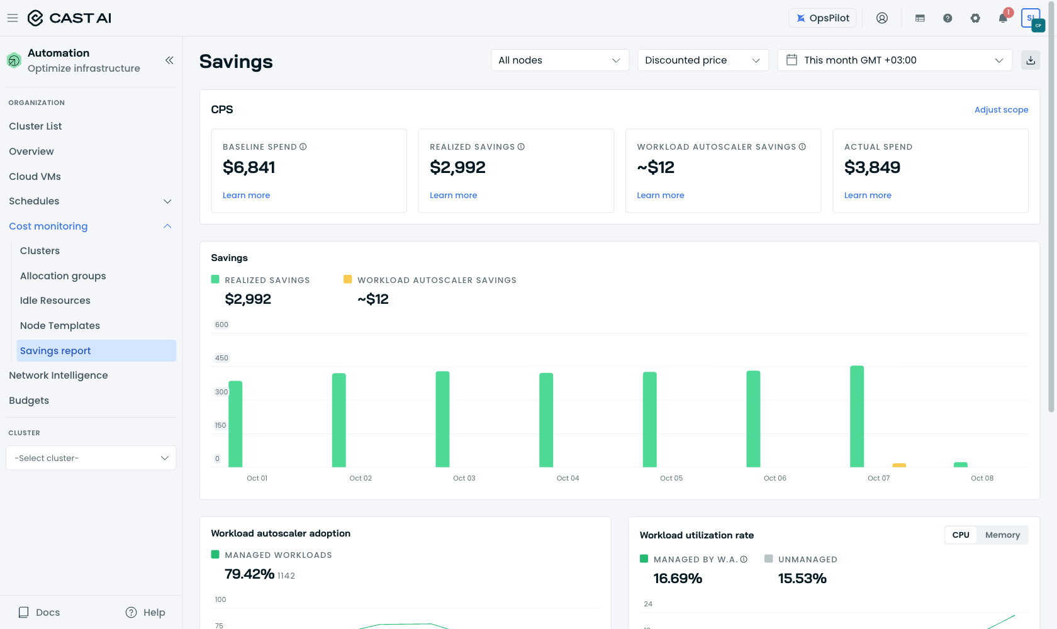
Proof 1: CPS Savings Report — this month (console, 2026-10-08 00:53 EET).
Claim 2 — Node Autoscaler is active on dema-platform-services; the lower score reflects remaining optimization opportunities.
For dema-platform-services, the Savings Report shows +$2,930 realized savings this month. Under "Node autoscaler impact", provisioned capacity is approximately 684 CPU at baseline versus 485 CPU actual, a reduction of about 199 CPU. Node Autoscaler has managed this cluster since July 22.
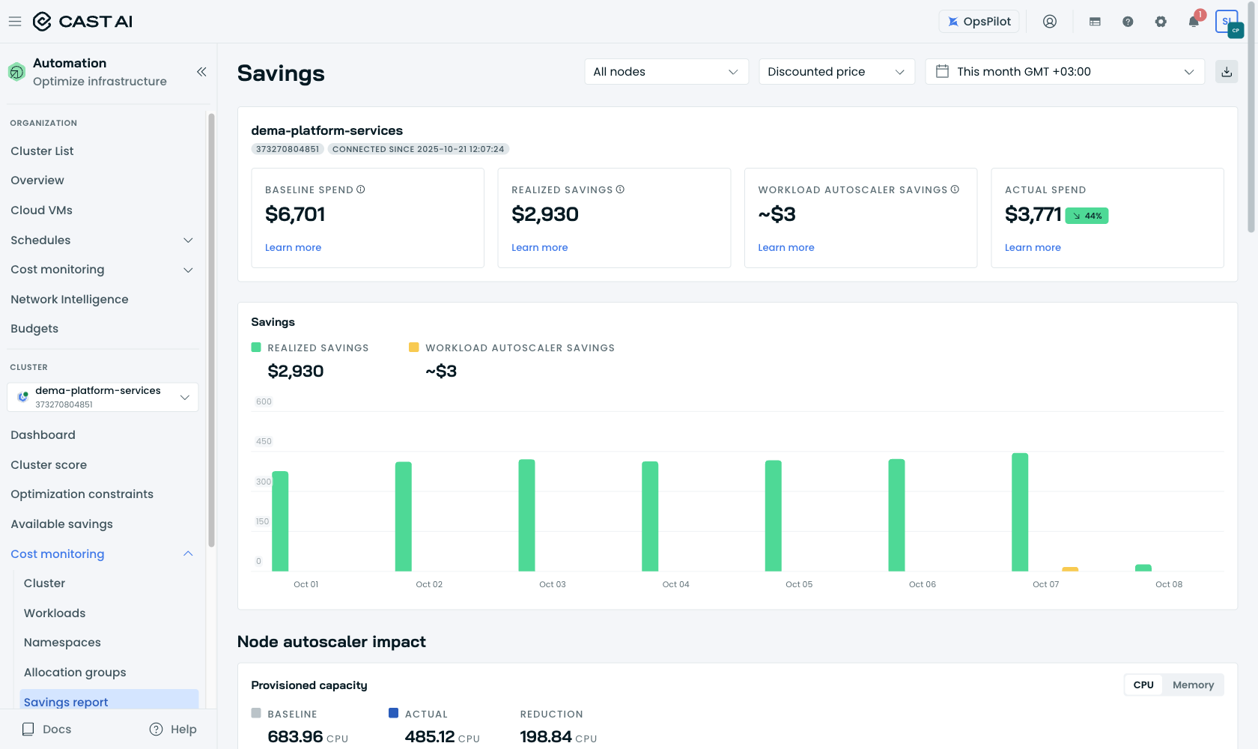
Proof 2a: dema-platform-services Savings Report (console, today).
The current cluster score is 4.9 (your earlier screenshot showed 4.6, so the score can move over time). The lower score does not indicate that Node Autoscaler is missing. It reflects remaining optimization opportunities, including 0% Spot usage and a pending rebalancing recommendation. The console currently estimates potential Spot savings of 48.7%–73.5% against the current ~$12.6k/month cost. This is potential optimization, not realized savings.
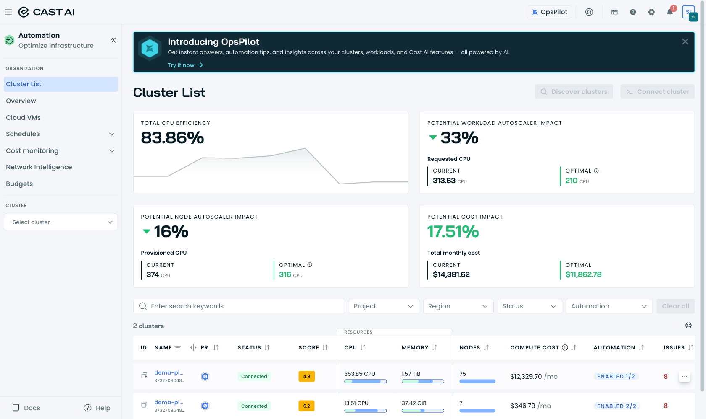
Proof 2b: Cluster list — current scores shown side by side (4.9 / 6.2).
Claim 3 — The small negative value is the Workload Autoscaler attribution, not negative total cluster savings.
Documented formula: https://docs.cast.ai/docs/savings-baseline
workload autoscaler savings = (original requests − current requests) × max(current price, baseline price)
On both clusters, Workload Autoscaler increased requests that had been set too low. The test cluster recorded 348 OOM kills in the last 30 days, which is consistent with under-requested memory. When current requests are higher than the original requests, the formula produces a negative Workload Autoscaler attribution. In August, that value was −$24.81 (approximately −€22), matching the figure you referenced.
1. This should not be read as an additional loss on top of the total savings figure. It is a sub-attribution within the savings report and reflects the cost impact of the workload rightsizing change.
2. For the test cluster, the Workload Autoscaler attribution turned positive on September 24 as rightsizing converged.
The same report for dema-platform-services-test currently shows +$66 realized savings (about 45% below baseline), with the Workload Autoscaler attribution at approximately +$9.
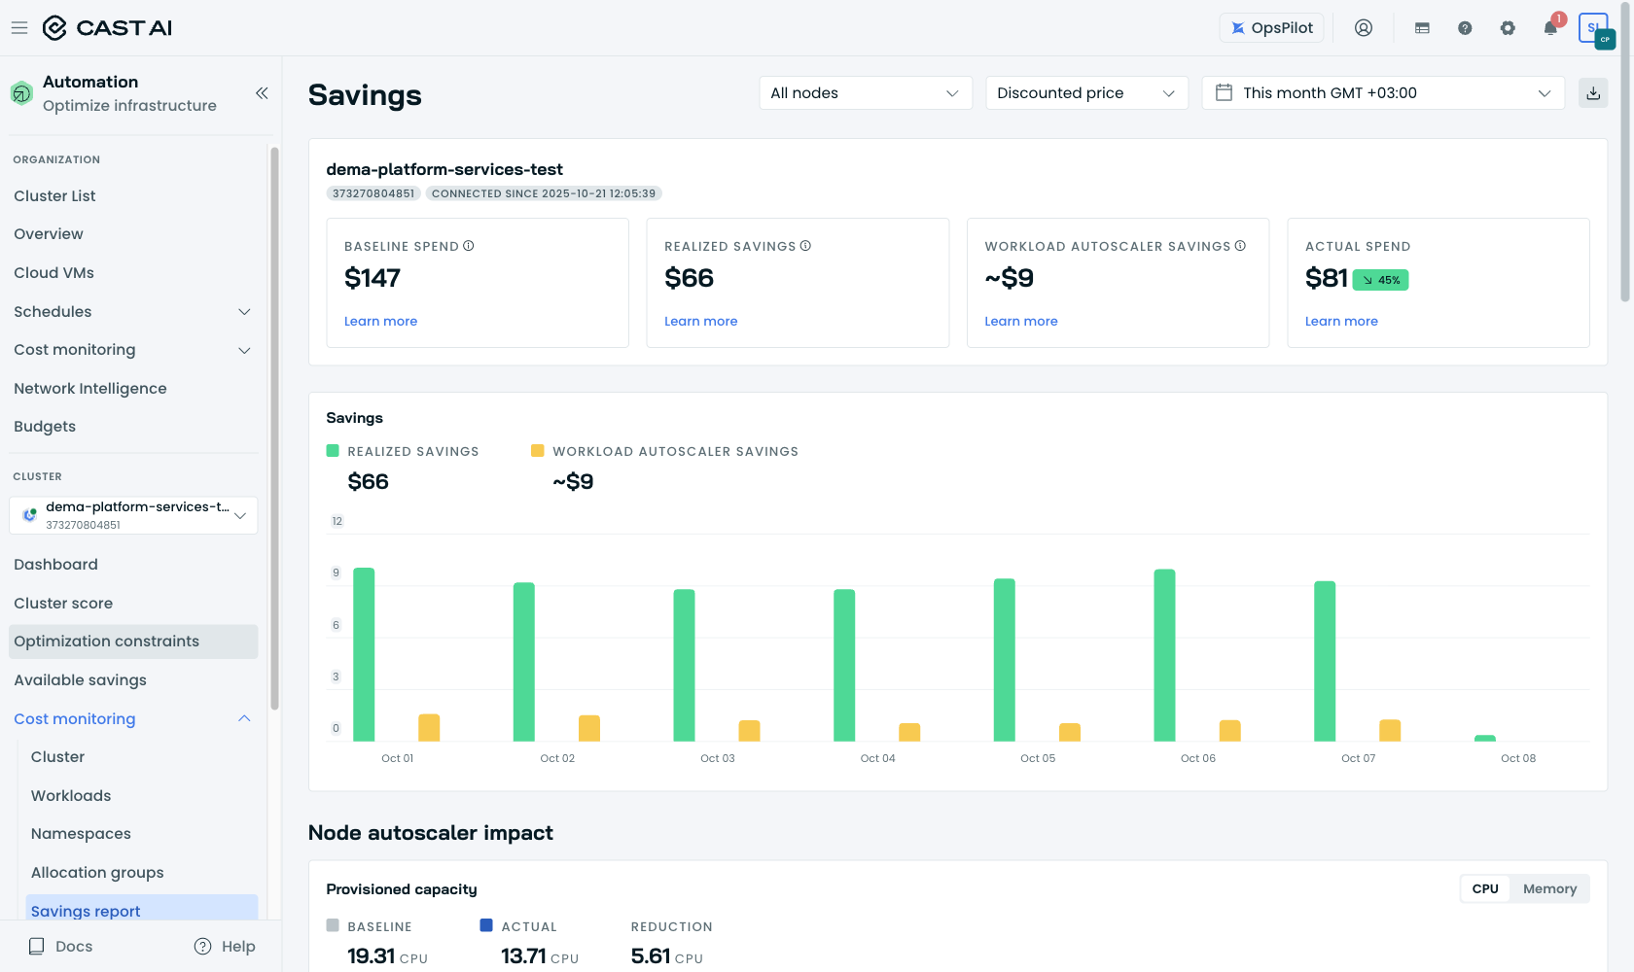
Proof 3: dema-platform-services-test Savings Report (console, today).
Monthly summary
Month | dema-platform-services — realized / workload line | dema-platform-services-test — realized / workload line
Jul 22–31 | +$2,567 / −$17 | +$70 / −$6
August | +$9,951 / −$75 | +$213 / −$25 (≈ −€22 ← your figure)
September | +$11,690 / −$81 | +$202 / −$9
October 1–8 (console today) | +$2,930 / ≈ +$3 | +$66 / ≈ +$9

Conclusion: both clusters currently show positive total realized savings. The negative value you saw was a temporary Workload Autoscaler sub-attribution caused by increasing under-sized workload requests; it should not be interpreted as the cluster being overall "in minus".
One additional note from our side: cloud-cost telemetry for both clusters has been stale since September 16, which can cause some report tiles to under-count. We are correcting this; no action is required from your side.
Sources: Savings Report — https://docs.cast.ai/docs/savings-report | Savings methodology and formulas — https://docs.cast.ai/docs/savings-baseline. Screenshots were taken on 2026-10-08 from your console; monthly history is from the CAST AI reporting API.

Best regards,
Ebrahim Ramadan
CAST AI — ebrahim@cast.ai

